Packet Tracer - Troubleshooting Switch Port Security

1. Topology

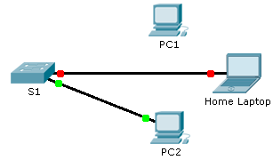

1. Scenario

The employee who normally uses PC1 brought his laptop from home, disconnected PC1 and connected the laptop to the telecommunication outlet. After reminding him of the security policy that does not allow personal devices on the network, you now must reconnect PC1 and re-enable the port.

1. Requirements

* Disconnect **Home Laptop** and reconnect **PC1** to the appropriate port.
  1. When **PC1** was reconnected to the switch port, did the port status change? ____________
  2. Enter the command to view the port status. What is the state of the port?

________________________________________________________________________________

* 1. Which port security command enabled this feature?

________________________________________________________________________________

* Enable the port using the necessary command.
* Verify connectivity. **PC1** should now be able to ping **PC2**.

1. Suggested Scoring Rubric

Packet Tracer scores 90 points. Answers to the questions are worth 10 points.